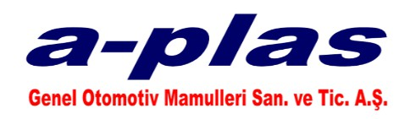

*- QUALITY POLICY -*

*A PLAS Genel Otomotiv Mamulleri San.Tic.A.Ş. as our aim; is to make customer satisfaction permanent by taking into account the legal condition. In order to achieve this aim;*

*- To provide timely and appropriate products to our customers,*



*- Prevent mistakes,*

*- To reduce variability and losses,*

*- Continuously improving the situation we are in,*

*-Doing the job right the first time,*

*- Taking responsibility*

*is our main goal.*

*CHAIRMAN OF THE BOARD*

*Ahmet AĞAOĞLU*

*POL-01/ Revision.No:1 / Rev.Date: 16.02.2021*